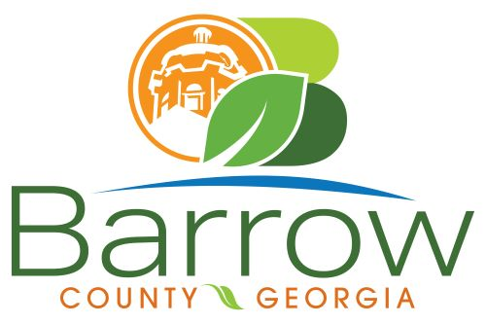

Barrow County
Board of Assessors
30 N. Broad St. * Winder, Georgia 30680 * (770) 307-3108

Ronnie Morrow Beth Buchanan Bernice Melton
Assessor Assessor Chairman

Barrow County Board of Assessors Agenda
June 12, 2024

- Call to Order:

- Approval of the May 8, 2024 Board of Assessors Meeting Minutes as written:

- Additions or Deletions:
- None

- Appointments:
- None

- Discussion and Consideration:
- Approval of ACO’s
- Approval of Homestead Exemptions
- Approval of Motor Vehicle Appeals
- Approval of Conservation Release
- Approval of Conservation Continuations
- Approval of Renewal and New Conservations
- Approval of Appeals Changes 30 day Notice
- Approval of Appeals No Change to BOE
- Appeal for – XX057-047H – HE VENTURES LLC

- Other Business:
- BOE Decision Sheets
- Monthly Activity Report
- Office Update

- Adjournment:

