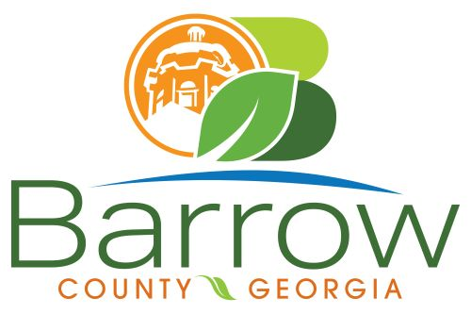

Barrow County
Board of Assessors
30 N. Broad St. * Winder, Georgia 30680 * (770) 307-3108

Ronnie Morrow Beth Buchanan Bernice Melton
Assessor Assessor Chairman

Barrow County Board of Assessors Agenda
July 10, 2024

- Call to Order:

- Approval of the June 12, 2024 Board of Assessors Meeting Minutes as written:

- Additions or Deletions:
- None

- Appointments:
- None

- Discussion and Consideration:
- Approval of ACO’s
- Approval of Homestead Exemptions
- Approval of Motor Vehicle Appeals
- Approval of Conservation Release
- Approval of Conservation Continuations
- Approval of Renewal and New Conservations
- Approval of Appeals Changes 30 day Notice
- Approval of Appeals No Change to BOE
- Approval of Exempt Property Application: XX107-006 – Bethlehem First Baptist Church, Inc.
- Approval of Tax Assessor’s Zero Tolerance Gossip Policy
- Approval of Freeport Exemptions

- Other Business:
- Monthly Activity Report
- Office Update

- Adjournment:

