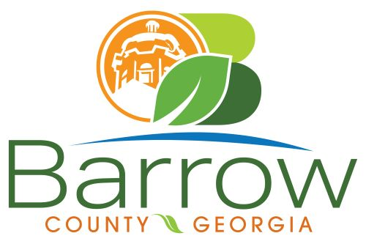

Barrow County
Board of Assessors
30 N. Broad St. * Winder, Georgia 30680 * (770) 307-3108

Ronnie Morrow Beth Buchanan Bernice Melton
Assessor Assessor Chairman

Barrow County Board of Assessors Agenda
July 24, 2024

- Call to Order:

- Discussion and Consideration:
- Approval of 2024 Digest
- Approval of Renewal and New Conservations
XX109-083 – Coker, Barry L and Coker, Barbara U – Timber Management Letter
XX042-033 – Slayton, Stephanie – Changed from Timber to Forestry.
XX038-004B – Dewitt, Vincent – 2023 appeal was granted by BOE without application conservation was denied for 2024. Submitted photos and forestry management for application for conservation.

- Adjournment:

