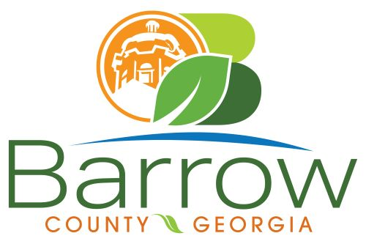

Barrow County
Board of Assessors
30 N. Broad St. * Winder, Georgia 30680 * (770) 307-3108

Ronnie Morrow Beth Buchanan Bernice Melton
Assessor Assessor Chairman

Barrow County Board of Assessors Agenda
August 14, 2024

- Call to Order:

- Approval of the July 10, 2024 and July 24, 2024 Board of Assessors Meeting Minutes as written:

- Additions or Deletions:
- None

- Appointments:
- None

- Discussion and Consideration:
- Approval of ACO’s
- Approval of Homestead Exemptions
- Approval of Motor Vehicle Appeals
- Approval of Renewal and New Conservations
XX109-083 – Coker, Barry L and Coker, Barbara U – Tabled Conservation Application until Timber Management Letter received.
- Approval of Appeals Changes 30 day Notice - NONE
- Approval of Appeals No Change to BOE - NONE
- CUVA Questions - XX080-039 – Beverly O Manders and Hubert Lamar Manders – 791 Moon Bridge Road, Winder GA 30680

- Other Business:
- Monthly Activity Report
- Office Update

- Adjournment:

