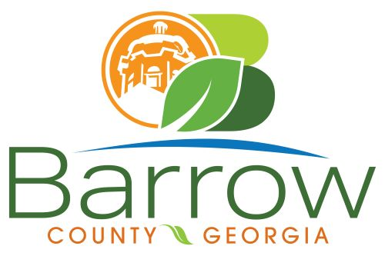

Barrow County
Board of Assessors
30 N. Broad St. * Winder, Georgia 30680 * (770) 307-3108

Ronnie Morrow Beth Buchanan Bernice Melton
Assessor Assessor Chairman

Barrow County Board of Assessors Agenda
January 14, 2025

- Call to Order:

- Approval of the December 11, 2024 Board of Assessors Meeting Minutes as written

- Additions or Deletions:
- None

- Appointments:
- None

- Selection of Officers for the Board of Assessors for 2025:
- Nominations for Secretary to the Barrow County Board of Assessors
- Nominations for Vice Chairman of the Barrow County Board of Assessors
- Nominations for Chairman of the Barrow County Board of Assessors

- Discussion and Consideration:
- Approval of ACO’s
- Approval of Homestead Exemptions
- Approval of Motor Vehicle Appeals
- Exempt Property Application – WN20-620 & WN20-418T - Winder Lions Club
- Approval of Conservation New and Renewal Applications
- Approval of Conservation Continuations

- Other Business:
- Monthly Activity Report
- Office Update
- 2025 Beginning Sales Ratios
- Veterans Homestead Exemption
- Social Security Maximum Exemption

- Adjournment:

