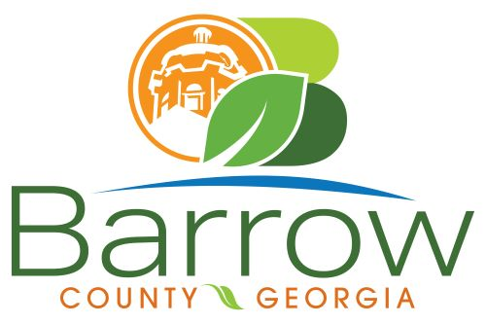

Barrow County
Board of Assessors
30 N. Broad St. * Winder, Georgia 30680 * (770) 307-3108

Ronnie Morrow Beth Buchanan Bernice Melton
Chairman Assessor Assessor

Barrow County Board of Assessors Agenda
February 12, 2025

- Call to Order:

- Approval of the January 14, 2025 Board of Assessors Meeting Minutes as written

- Additions or Deletions:
- None

- Appointments:
- None

- Discussion and Consideration:
- Approval of ACO’s
- Approval of Homestead Exemptions
- Approval of Motor Vehicle Appeals
- Approval of Conservation New and Renewal Applications
- Approval of Conservation Continuations

- Other Business:
- Monthly Activity Report
- Office Update

- Executive Session:

- Adjournment:

