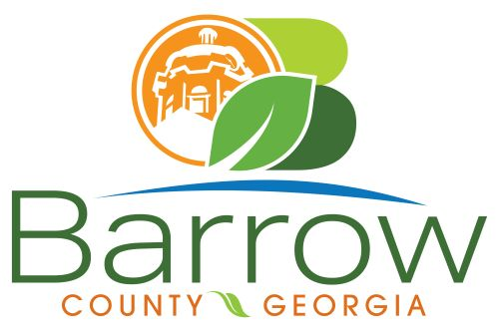

Barrow County
Board of Assessors
30 N. Broad St. * Winder, Georgia 30680 * (770) 307-3108

Ronnie Morrow Beth Buchanan Bernice Melton
Chairman Assessor Assessor

Barrow County Board of Assessors Agenda
March 11, 2025

- Call to Order:

- Approval of the February 12, 2025 Board of Assessors Meeting Minutes as written

- Additions or Deletions:
- None

- Appointments:
- None

- Discussion and Consideration:
- Approval of ACO’s
- Approval of Homestead Exemptions
- Approval of Motor Vehicle Appeals
- Exempt Property Application – XX004-029 Atlanta General Education Center, Inc.
- Exempt Property Application – XX049F-033 and XX049F-034 Vital Signs Economic Stability Training, Inc
- Approval of Conservation New and Renewal Applications
- Approval of Conservation Continuations

- Other Business:
- Monthly Activity Report
- Office Update

- Adjournment:

