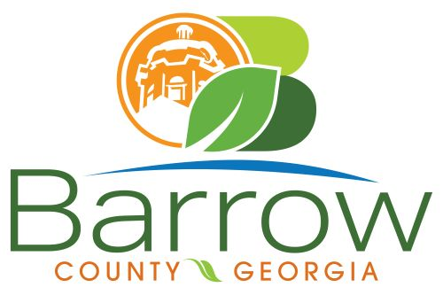

Barrow County
Board of Assessors
30 N. Broad St. * Winder, Georgia 30680 * (770) 307-3108

Ronnie Morrow Beth Buchanan Bernice Melton
Chairman Assessor Assessor

Barrow County Board of Assessors Agenda
April 8, 2025

- Call to Order:

- Approval of the March 11, 2025 Board of Assessors Meeting Minutes as written

- Approval of the March 27, 2025 Board of Assessors Executive Meeting Minutes as written

- Additions or Deletions:
- None

- Appointments:
- None

- Discussion and Consideration:
- Approval of ACO’s
- Approval of Homestead Exemptions
- Approval of Tabled Homestead Exemptions
- Approval of Motor Vehicle Appeals
- Approval of Exempt Property Application for XX053-031H - Northeast Georgia Health System, Inc
- Approval of Conservation New and Renewal Applications
- Approval of Conservation Continuations
- Approval of Tabled Conservation Continuation for BE05-029
- Approval of Conservation under 10 Acres for New, Renewal, and Continuations
- Approval of the Adoption of the 2025 Conservation use and FLPA soil values

- Other Business:
- Monthly Activity Report
- Office Update

- Adjournment:

