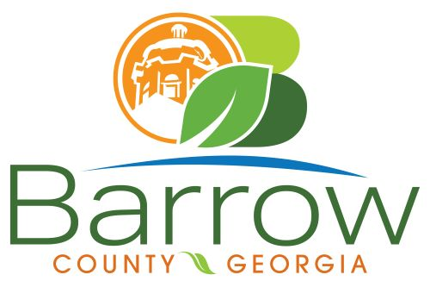

Barrow County
Board of Assessors
30 N. Broad St. * Winder, Georgia 30680 * (770) 307-3108

Ronnie Morrow Beth Buchanan Bernice Melton
Chairman Assessor Assessor

Barrow County Board of Assessors Agenda
May 14, 2025

- Call to Order:

- Approval of the April 8, 2025 Board of Assessors Meeting Minutes as written

- Additions or Deletions:
- None

- Appointments:
- None

- Discussion and Consideration:
- Approval of ACO’s
- Approval of Homestead Exemptions
- Approval of Senior Homestead Exemptions for January, February, and March
- Approval of Tabled Homestead Exemptions from April 8, 2025 Meeting
- Approval of Motor Vehicle Appeals
- Approval of Conservation New and Renewal Applications and April Tabled
- Approval of Conservation Continuations
- Approval of Conservation under 10 Acres for New, Renewal, and Continuations and April Tabled
- Intent to Breach Letters
- Freeport Exemptions Approval
- Approval of Exempt Property Digest (Real and Personal)
- Adoption of the Zero Tolerance Gossip Policy
- Final Sales Ratios for 2025
- Approval of the Real and Personal Property Notice of Assessments.

- Other Business:
- Monthly Activity Report
- Office Update

- Adjournment:

