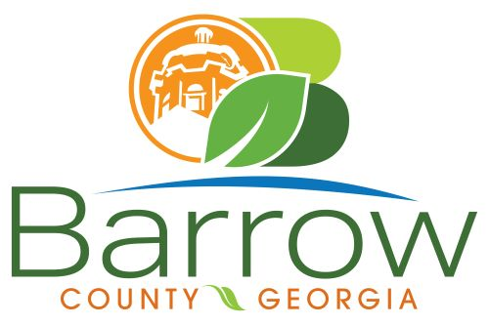

Barrow County
Board of Assessors
30 N. Broad St. * Winder, Georgia 30680 * (770) 307-3108

Ronnie Morrow Beth Buchanan Bernice Melton
Chairman Assessor Assessor

Barrow County Board of Assessors Agenda
September 17, 2025

- Call to Order:

- Approval of the August 13, 2025 Board of Assessors Meeting Minutes as written

- Additions or Deletions:
- None

- Appointments:
- None

- Discussion and Consideration:
- Approval of ACO’s
- Approval of Homestead Exemptions
- Approval of Motor Vehicle Appeals
- Approval of the Three Tabled Motor Vehicle Appeals from the August Meeting
- Approval of Exempt Property Application: XX053L-081 House Of Prayer Trust
- Approval of Appeals Changes 30 Day Notice
- Approval of No Changes to BOE
- Policy Manual

- Other Business:
- Monthly Activity Report
- Office Update

- Adjournment:

