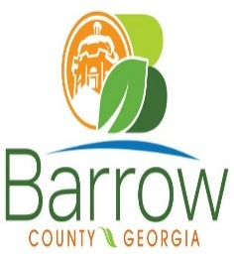

Barrow County
Board of Assessors
30 N. Broad St. * Winder, Georgia 30680 * (770) 307-3108

Ronnie Morrow Beth Buchanan Bernice Melton
Chairman Assessor Assessor

Barrow County Board of Assessors Agenda
Special Called Meeting - Executive Session
July 8, 2026

- Call to Order:

- Executive Session:
Executive Session allows discussion of discuss matters properly excluded from the
Georgia Open and Public Meetings Law (O.C.G.A. §50-14), specifically:
Pending or potential litigation, settlement, claims, administrative proceedings or
other judicial actions,
Discussion of future acquisition, disposition, or lease of real estate
Discussing or deliberating upon the appointment, employment, hiring, disciplinary
action or dismissal, or performance of a public officer or employee
Discussion of a record exempt from disclosure where consideration of the record
cannot be had without disclosure of the record

No action will be taken during this session.

- Adjournment:

