Individual Personal Property Business Assets & Property
(boat/jet ski/aircraft) (machinery/equipment/inventory/freeport)
ipp.taxscribe.app/ga/county/barrow bpp.taxscribe.app/ga/county/barrow



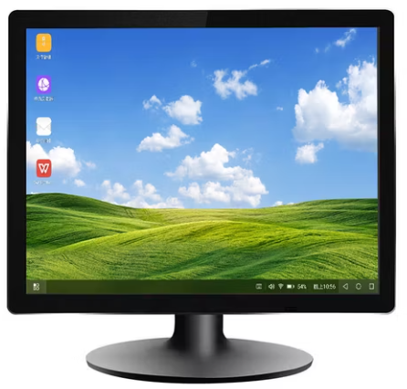


Taxscribe simplifies the filing of annual returns for business inventory, assets and freeport; as well as personal property such as watercraft and aircraft.

Filing online is a convenient process that saves time and eliminates stress.
- Validate data online
- Manage multiple listings
- Attach additional files

Receive email notification when your submission has been viewed and accepted.
Filing your Business Asset / Personal Property annual return has never been easier.

